REQUIREMENTS OF PRICING PROJECT:

1. WE WILL HAVE DATA MODELS (STORING THE DATA) AND MAPPING (COLUMN FROM SOURCE TO TARGET TABLE) – PROFILING EXERCISE
2. WHAT ARE THE DEPENDENCY FOR THIS PROJECT
3. OFFICIAL COMMUNICATION IS VERY IMPORTANT FOR THIS PROJECT
4. PROWL AND STACKLINE
5. AS SOON AS WE GET THE MODELS AND TABLES (PHYSICAL IN DEVELOPMENT)
6. FOLLOW THE WORKSTREAMS
7. MAPPING DOC DONE BY DEVELOPMENT TEAM
8. WHAT IS UPSTREAM AND DOWN STREAM ?
9. Data governance , co-build person, project manager, deleiverable regarding project
10. Structures available in dev and test environment (deadline)
11. Daily stand up call for this project
12. People working on brds(source brds and consolidated brds)
13. Don’t go with mpm (projects)
14. Querying the tables is the first step of the project
15. Timeline for the next week (Tuesday)
16. url features and days (to be excluded), weekid to be stored as target

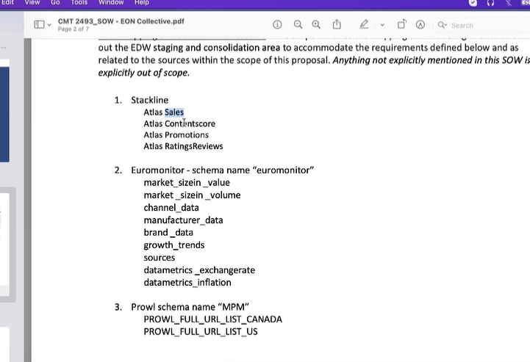

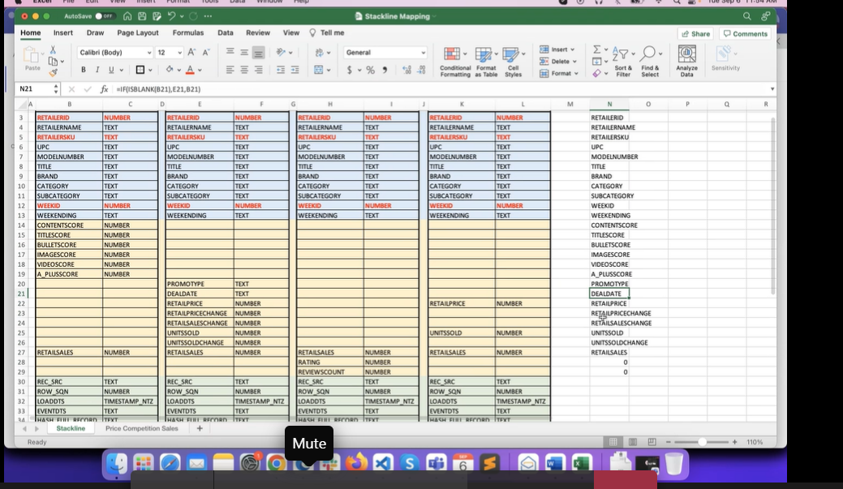

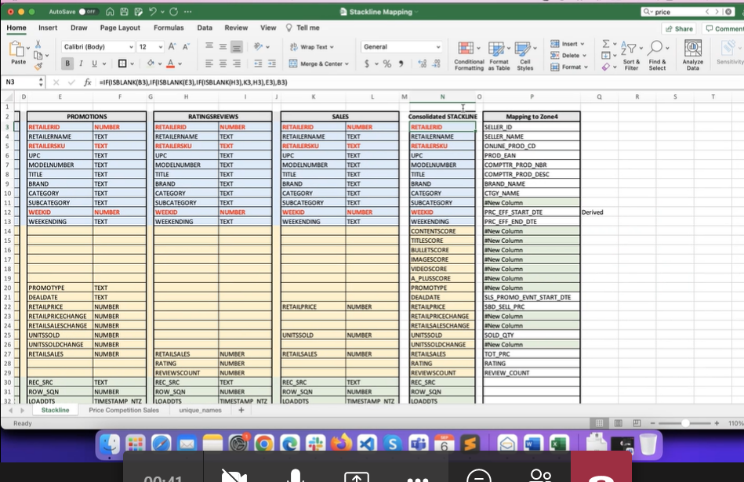

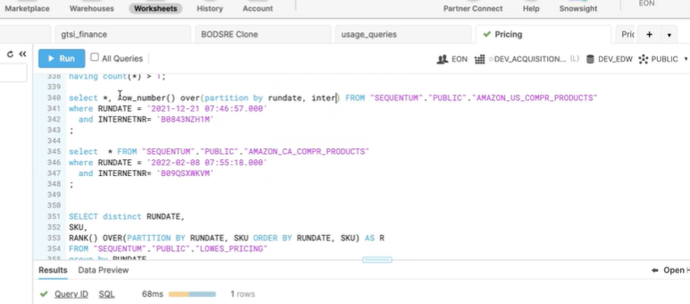

DDL OF THE TABLES IN CONSOLIDTED SCHEMA:

1.select get_ddl('TABLE', 'US');

create or replace TABLE US (

ORIG_SYSTEM VARCHAR(50),

FILLER VARCHAR(50),

SOLD_TO_CUSTOMER_NBR VARCHAR(50),

STORE_NUMBER VARCHAR(100),

CUSTOMER_MATERIAL VARCHAR(50),

UPC_NUMBER VARCHAR(50),

MATERIAL_NUMBER VARCHAR(50),

RETAIL__EXTD_DOLLARS NUMBER(38,10),

POS_QTY NUMBER(10,0),

BOH_QTY NUMBER(10,0),

ON_ORDER_QTY NUMBER(10,0),

BEGINNING_DATE VARCHAR(15),

END_DATE VARCHAR(15),

LOADDTS TIMESTAMP_NTZ(9),

EVENTDTS VARCHAR(16777216),

REC_SRC VARCHAR(16777216),

ROW_SQN NUMBER(38,0),

HASH_FULL_RECORD VARCHAR(128)

);

2. select get_ddl('TABLE', 'EDW_PRICING_COMPETITOR_SALES');

create or replace TABLE EDW_PRICING_COMPETITOR_SALES (

SRC_SYS_KEY VARCHAR(255) NOT NULL COMMENT 'Identifies the origin of data source, in other word source system from where data is brought. The Key will be available in Source System table where one entry will exist for each participating system.\n',

PRC_COMPTTR_SLS_KEY VARCHAR(255) NOT NULL COMMENT 'Key Identifier to make the Pricing Competitor Sales record Unique and This Column serves as Primary Key constraint on the Table and is generated by Concatinating (Competitor Product ID,SourceSystem Code, Store Name, RUN DATE) ',

SRC_RCRD_CREATE_DTE TIMESTAMP_NTZ(9) COMMENT 'Date and time when this record was created at source system table (driver table in case of multiple table/files are involved). NULL if not available at source. ',

SRC_RCRD_CREATE_USERID VARCHAR(255) COMMENT 'The ID of the user who created the record at the at source system table (driver table in case of multiple table/files are involved). NULL if not available at source. ',

SRC_RCRD_UPD_DTE TIMESTAMP_NTZ(9) COMMENT 'Date and time when this record was updated at source system table (driver table in case of multiple table/files are involved). ',

SRC_RCRD_UPD_USERID VARCHAR(255) COMMENT 'The ID of the user who updated the record at the at source system table (driver table in case of multiple table/files are involved). ',

RCRD_HASH_KEY VARCHAR(255) COMMENT 'The hash value (MD5/SHA256/etc.) of the qualified columns, that is considered to be different to enable versioning of record, will be stored in this column. ',

VER_EFF_DTE TIMESTAMP_NTZ(9) COMMENT 'Date and time when this version of the record is created and become effective or valid ',

VER_EXPR_DTE TIMESTAMP_NTZ(9) COMMENT 'Date and time when this version of the record has expired and no longer effective or valid at the target ',

CURR_RCRD_FLAG VARCHAR(1) COMMENT 'Default =\"Y\". This flag Indicates if the version of record is current or obsolete. “Y” indicates that the record is current and “N” indicates the record is obsolete or old. ',

ORP_RCRD_FLAG VARCHAR(1) COMMENT 'Default =\"N\". This flag indicates if the record is orphan (master/reference data information is missing). “Y” indicates that the record is orphan, and some program has created this record with missing/dummy key value in the Master/Reference table to maintain integrity. When the actual record arrives from its parent source, the column values are updated and this flag is set as “N”. ',

DEL_FROM_SRC_FLAG VARCHAR(1) COMMENT 'Default =\"N\". When it is detected that the record has been deleted from the source table, then the corresponding record at target is marked as delete (soft delete) setting the flag as “Y”. (“U” à The status of record is unknown in terms of record deleted from source.) ',

ETL_INS_PID VARCHAR(255) COMMENT 'Contains information about the ETL/ELT job & package which has created the record ',

ETL_INS_DTE TIMESTAMP_NTZ(9) COMMENT 'Date and time when this record is created or inserted at the target table. ',

ETL_UPD_PID VARCHAR(255) COMMENT 'Contains information about the ETL/ELT job & package which has updated the record last time (may be removed if ETL architect confirms) ',

ETL_UPD_DTE TIMESTAMP_NTZ(9) COMMENT 'When Insert this will be NULL. Date and time when this record is updated last time at the target table. ',

ZONE3_LOD_DTE TIMESTAMP_NTZ(9) COMMENT 'Zone3 Load DateTime (This will be used in ETL load from Zone 3 to Snowflake)',

PRC_EFF_START_DTE TIMESTAMP_NTZ(9) COMMENT 'Recorded date is the cut-off date established to determine the day price is updated or created. This field provides the date on which the data was recorded. ',

PRC_EFF_END_DTE TIMESTAMP_NTZ(9) COMMENT 'Business: >> This colum should update transformation as \"Effective start date - 1\"',

PROD_KEY VARCHAR(255) DEFAULT 'N/A' COMMENT 'This field provides the SBD product model number',

COMPTTR_PROD_NBR VARCHAR(255) COMMENT 'This field provides the product model number of the competitor',

CRNCY_KEY VARCHAR(255) DEFAULT 'N/A' COMMENT 'This field is an Currency to show which currency is being used. ',

BRAND_LKEY VARCHAR(255) DEFAULT 'N/A' COMMENT 'Brand is type of product manufactured by a particular company under a particular name.This field provides the brand name of the product.',

COMPTTR_BRAND_LKEY VARCHAR(255) DEFAULT 'N/A' COMMENT 'Brand name of the competitor product is provided in this field',

CUST_CHNL_LKEY VARCHAR(255) DEFAULT 'N/A' COMMENT 'This field provides the customer channel method used.\nThe Customer Channels is the building block that describes how a company communicates with its Customer Segments to deliver a Value Proposition.',

SBU_LKEY VARCHAR(255) DEFAULT 'N/A' COMMENT 'This field provides the Store Business Unit from which the product is sold',

SLS_PROMO_EVNT_START_DTE TIMESTAMP_NTZ(9) COMMENT 'The date on which the event takes place',

SLS_PROMO_END_MAP_DTE TIMESTAMP_NTZ(9) COMMENT 'This field provides the date and time on which the sales monitoring ends.',

SLS_PROMO_START_DTE TIMESTAMP_NTZ(9) COMMENT 'This field provides the date and time on which the sales monitoring starts',

SLS_PROMO_END_DTE TIMESTAMP_NTZ(9) COMMENT 'This field provides the date and time on which the sales monitoring ends',

COMPTTR_PROD_PRC NUMBER(28,10) COMMENT 'This field provides the price of the product\nPricing of the product is something different from its price. In simple words, pricing is the art of translating into quantitative terms the value of a product to customers at a point of time. ',

COMPTTR_PROMO_PRC NUMBER(28,10) COMMENT 'This field provides the price of the product after the promotion is applied.\nA price promotion is a reduced price that is intended to increase sales.',

VAT_PRC NUMBER(28,10) COMMENT 'This field provides the Value Added Tax price\nValue Added Tax is a type of tax that is charged by the Central Government on the sale of services and goods to the consumers. It is commonly expressed as a percentage of the total cost',

PROD_LIST_PRC NUMBER(28,10) COMMENT 'Product Price is the price as of the time we pull the data.\nThe list price is the price that the manufacturer of an item suggests that a store should charge for it. SIMILAR WORDS: retail price',

VAT_PROMO_PRC NUMBER(28,10) COMMENT 'This field provides the Value Added Tax promotion price',

VAT_LIST_PRC NUMBER(28,10) COMMENT 'Gives the Value Added Tax list price',

SBD_PROD_DESC VARCHAR(2000) COMMENT 'This field give the description of the SBD product.',

COMPTTR_STORE_NAME VARCHAR(255) COMMENT 'The name of the store where the competitors product is sold',

ONLINE_SELLER_NAME VARCHAR(255) COMMENT 'The name of the store where the SBD product is sold.',

ONLINE_PROD_CD VARCHAR(255) COMMENT 'The price at which the SBD product is being sold',

SBD_STORE_NAME VARCHAR(255) COMMENT 'The name of the store where the SBD product is sold.',

SBD_SELL_PRC NUMBER(28,10) COMMENT 'The price at which the SBD product is being sold',

constraint EDW_PRICING_COMPETITOR_SALES_PK_IDX primary key (SRC_SYS_KEY, PRC_COMPTTR_SLS_KEY)

);

STEPS IN CREATING PROWL_CANADA_MODEL_IN_DBT

1. FIRST CREATE COMPETITOR SALES PRICE TABLE WITH NEW COLS AND WITH THAT SCRIPT WE NEED CREATE TABLE IN SNOWFLAKE
2. CLONE THE REPO FROM SBD GITHUB REPO (sbd_edw-pricing) IN TO LOCAL CREATED FOLDER
3. (FOR CANADA) WE HAVE TO CREATE MODEL (.SQL) FILE WITH ALL THE COLS OF PROWL CANADA AND WITH CONCAT VALUE AS WELL
4. Git pull (to push any changes in the main or branch) of sbd repo
5. Git status
6. Git fetch
7. Git switch to another repo or branch
8. Git check out (file name) to take it out of the repo)
9. Finally dbt debug
10. Dbt run -m Canada view file name undr source
11. Columns name to be renamed in dbt_project.yml (errors)
12. Source not found (git pull)
13. Dbt_packages folder to be added in sbd-edw-pricing folder (under that sbd-edw-main)
14. Dbt_project.yml (to be configured here as well)
15. Run dbt debug
16. Run dbt run -m Canada table name
17. Table created at snowflake

Concat of only retailersku

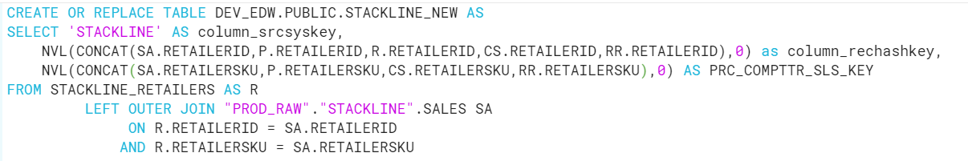

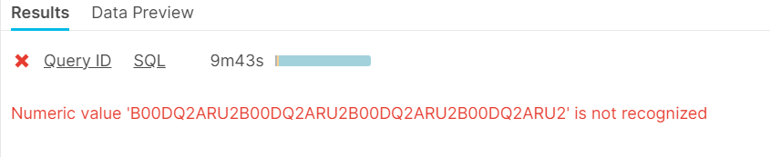

Output of stackline:

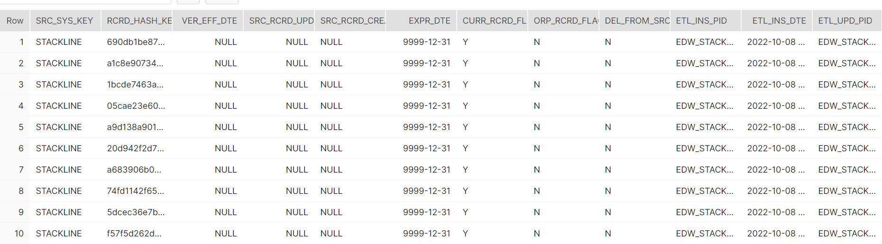

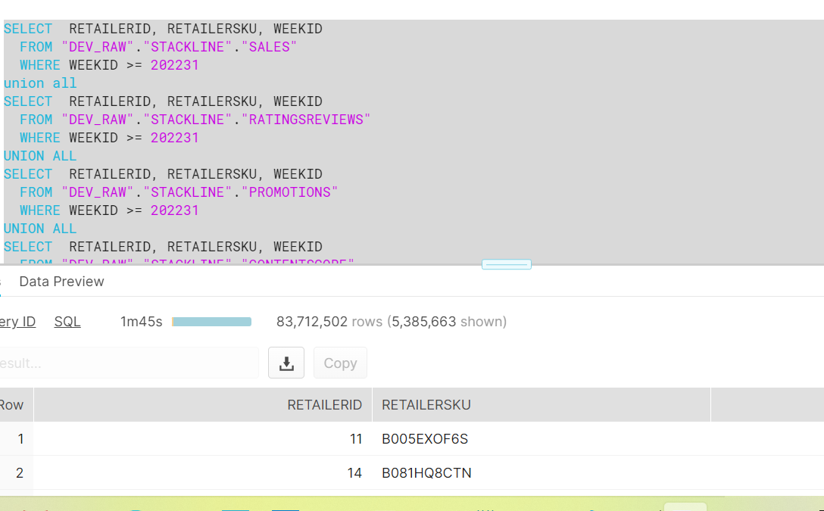

To test the source count (from DEV_RAW)

-- ORIGINAL VIEW CODE

WITH STACKLINE_RETAILERS AS

( SELECT RETAILERID,

RETAILERSKU,

WEEKID

FROM "DEV_RAW"."STACKLINE"."SALES"

WHERE WEEKID >= 202231

UNION

SELECT RETAILERID,

RETAILERSKU,

WEEKID

FROM "DEV_RAW"."STACKLINE"."PROMOTIONS"

WHERE WEEKID >= 202231

UNION

SELECT RETAILERID,

RETAILERSKU,

WEEKID

FROM "DEV_RAW"."STACKLINE"."RATINGSREVIEWS"

WHERE WEEKID >= 202231

UNION

SELECT RETAILERID,

RETAILERSKU,

WEEKID

FROM "DEV_RAW"."STACKLINE"."CONTENTSCORE"

WHERE WEEKID >= 202231

)

SELECT COUNT(*) as SOURCE_COUNT FROM STACKLINE_RETAILERS AS R

-- SEQUENTUM

USE DATABASE SEQUENTUM

SELECT * FROM "DEV_EDW"."CONSOLIDATED"."EDW_PRICING_COMPETITOR_SALES" WHERE SRC_SYS_KEY = 'SEQUENTUM' LIMIT 20

show primary keys in "DEV_EDW"."CONSOLIDATED"."EDW_PRICING_COMPETITOR_SALES"

select * from "SEQUENTUM"."PUBLIC"."AMAZON_CA_COMPR_PRODUCTS" limit 10

SHOW PRIMARY KEYS IN "SEQUENTUM"."PUBLIC"."AMAZON_CA_COMPR_PRODUCTS"

SHOW PRIMARY KEYS IN "SEQUENTUM"."PUBLIC"."AMAZON_US_COMPR_PRODUCTS"

SHOW PRIMARY KEYS IN "SEQUENTUM"."PUBLIC"."LOWES_COMPR_PRODUCTS"

-- target

select COUNT(*) as "Target_Count" from DEV_EDW.CONSOLIDATED.EDW_PRICING_COMPETITOR_SALES WHERE SRC_SYS_KEY = 'SEQUENTUM'

select count(*) AS TARGET_COUNT

from DEV_EDW.CONSOLIDATED.EDW_PRICING_COMPETITOR_SALES

where SRC_SYS_KEY = 'SEQUENTUM'

group by 1

limit 10;

desc table DEV_EDW.CONSOLIDATED.EDW_PRICING_COMPETITOR_SALES

-- SOURCE SOUNT

select SRC_SYS_KEY from DEV_EDW.CONSOLIDATED.EDW_PRICING_COMPETITOR_SALES WHERE COUNT(*) > 1 AND SRC_SYS_KEY = 'SEQUENTUM' AND COUNT(*) > 1

select 'CA', COUNT(*) AS SOURCE_COUNT

from "SEQUENTUM"."PUBLIC"."AMAZON_CA_COMPR_PRODUCTS"

UNION ALL

select 'US', COUNT(*) AS SOURCE_COUNT

from "SEQUENTUM"."PUBLIC"."AMAZON_US_COMPR_PRODUCTS"

UNION ALL

select 'CA', COUNT(*) AS SOURCE_COUNT

from "SEQUENTUM"."PUBLIC"."LOWES_COMPR_PRODUCTS"

UNION ALL

select 'US', COUNT(*) AS SOURCE_COUNT

from "SEQUENTUM"."PUBLIC"."HOMEDEPOT_COMPR_PRODUCTS"

UNION ALL

select 'US', COUNT(*) AS SOURCE_COUNT

from "SEQUENTUM"."PUBLIC"."HOMEDEPOT_PRICING"

UNION ALL

select 'US', COUNT(*) AS SOURCE_COUNT

from "SEQUENTUM"."PUBLIC"."LOWES_PRICING"

-- source count

WITH DEDUPE_SRC_AMZ_US as (

SELECT *,

ROW_NUMBER() OVER(PARTITION BY INTERNETNR, MODELNR, ITEMMODELNUMBER, ITEMURL, RUNDATE

ORDER BY INTERNETNR, MODELNR, ITEMMODELNUMBER, ITEMURL, RUNDATE, ROW_SQN DESC) AS ROW_NO

FROM DEV_RAW.SEQUENTUM.VW_AMAZON_US_COMPR_PRODUCTS

), DEDUPE_SRC_AMZ_CA as (

SELECT *,

ROW_NUMBER() OVER(PARTITION BY INTERNETNR, MODELNR, ITEMMODELNUMBER, ITEMURL, RUNDATE

ORDER BY INTERNETNR, MODELNR, ITEMMODELNUMBER, ITEMURL, RUNDATE, ROW_SQN DESC) AS ROW_NO

FROM DEV_RAW.SEQUENTUM.VW_AMAZON_CA_COMPR_PRODUCTS

), DEDUPE_SRC_LS_PRC as (

SELECT *,

ROW_NUMBER() OVER(PARTITION BY SKU, MODELNUMBER, ITEMBRAND, ITEMURL, RUNDATE

ORDER BY SKU, MODELNUMBER, ITEMBRAND, ITEMURL, RUNDATE, ROW_SQN DESC) AS ROW_NO

FROM DEV_RAW.SEQUENTUM.VW_LOWES_PRICING

), DEDUPE_SRC_HD_PRC as (

SELECT *,

ROW_NUMBER() OVER(PARTITION BY SKU, MODELNUMBER, ITEMBRAND, ITEMURL, RUNDATE

ORDER BY SKU, MODELNUMBER, ITEMBRAND, ITEMURL, RUNDATE, ROW_SQN DESC) AS ROW_NO

FROM DEV_RAW.SEQUENTUM.VW_HOMEDEPOT_PRICING

), DEDUPE_SRC_HD_COMPR as (

SELECT *,

ROW_NUMBER() OVER(PARTITION BY INTERNETNR, MODELNR, ITEMBRAND, ITEMURL, RUNDATE

ORDER BY INTERNETNR, MODELNR, ITEMBRAND, ITEMURL, RUNDATE, ROW_SQN DESC) AS ROW_NO

FROM DEV_RAW.SEQUENTUM.VW_HOMEDEPOT_COMPR_PRODUCTS

), DEDUPE_SRC_LS_COMPR as (

SELECT *,

ROW_NUMBER() OVER(PARTITION BY INTERNETNR, MODELNR, ITEMBRAND, ITEMURL, RUNDATE

ORDER BY INTERNETNR, MODELNR, ITEMBRAND, ITEMURL, RUNDATE, ROW_SQN DESC) AS ROW_NO

FROM DEV_RAW.SEQUENTUM.VW_LOWES_COMPR_PRODUCTS

)

SELECT 'AMZ_US', COUNT(*)

FROM DEDUPE_SRC_AMZ_US --1

WHERE ROW_NO = 1

UNION ALL

SELECT 'AMZ_CA', COUNT(*)

FROM DEDUPE_SRC_AMZ_CA --2

WHERE ROW_NO = 1

UNION ALL

SELECT 'HD_PRC', COUNT(*)

FROM DEDUPE_SRC_HD_PRC --3

WHERE ROW_NO = 1

UNION ALL

SELECT 'LS_PRC', COUNT(*)

FROM DEDUPE_SRC_LS_PRC --4

WHERE ROW_NO = 1

UNION ALL

SELECT 'HD_COMPR', COUNT(*)

FROM DEDUPE_SRC_HD_COMPR --5

WHERE ROW_NO = 1

UNION ALL

SELECT 'LS_COMPR', COUNT(*)

FROM DEDUPE_SRC_LS_COMPR --6

WHERE ROW_NO = 1;

{% macro ReleaseObjects() %}

USE SCHEMA CONSOLIDATED;

USE DATABASE DEV_RAW

USE SCHEMA STACKLINE

SELECT * FROM SALES LIMIT 10

SELECT * FROM

select 'IFNULL(NULL,LOADDTS)' Condition ,IFNULL(MODELNUMBER,'') FROM SALES LIMIT 1000

create or replace temporary table EDW_PRICING_COMPETITOR_SALES (

SRC_SYS_KEY VARCHAR(255) NOT NULL COMMENT 'Identifies the origin of data source, in other word source system from where data is brought. The Key will be available in Source System table where one entry will exist for each participating system.\n',

PRC_COMPTTR_SLS_KEY VARCHAR(2000) NOT NULL COMMENT 'Key Identifier to make the Pricing Competitor Sales record Unique and This Column serves as Primary Key constraint on the Table and is generated by Concatinating (Competitor Product ID,SourceSystem Code, Store Name, RUN DATE) ',

SRC_RCRD_CREATE_DTE TIMESTAMP_NTZ(9) COMMENT 'Date and time when this record was created at source system table (driver table in case of multiple table/files are involved). NULL if not available at source. ',

SRC_RCRD_CREATE_USERID VARCHAR(255) COMMENT 'The ID of the user who created the record at the at source system table (driver table in case of multiple table/files are involved). NULL if not available at source. ',

SRC_RCRD_UPD_DTE TIMESTAMP_NTZ(9) COMMENT 'Date and time when this record was updated at source system table (driver table in case of multiple table/files are involved). ',

SRC_RCRD_UPD_USERID VARCHAR(255) COMMENT 'The ID of the user who updated the record at the at source system table (driver table in case of multiple table/files are involved). ',

RCRD_HASH_KEY VARCHAR(255) COMMENT 'The hash value (MD5/SHA256/etc.) of the qualified columns, that is considered to be different to enable versioning of record, will be stored in this column. ',

EFF_DTE TIMESTAMP_NTZ(9) COMMENT 'Date and time when this version of the record is created and become effective or valid ',

EXPR_DTE TIMESTAMP_NTZ(9) COMMENT 'Date and time when this version of the record has expired and no longer effective or valid at the target ',

CURR_RCRD_FLAG VARCHAR(1) COMMENT 'Default =\"Y\". This flag Indicates if the version of record is current or obsolete. “Y” indicates that the record is current and “N” indicates the record is obsolete or old. ',

ORP_RCRD_FLAG VARCHAR(1) COMMENT 'Default =\"N\". This flag indicates if the record is orphan (master/reference data information is missing). “Y” indicates that the record is orphan, and some program has created this record with missing/dummy key value in the Master/Reference table to maintain integrity. When the actual record arrives from its parent source, the column values are updated and this flag is set as “N”. ',

DEL_FROM_SRC_FLAG VARCHAR(1) COMMENT 'Default =\"N\". When it is detected that the record has been deleted from the source table, then the corresponding record at target is marked as delete (soft delete) setting the flag as “Y”. (“U” à The status of record is unknown in terms of record deleted from source.) ',

ETL_INS_PID VARCHAR(255) COMMENT 'Contains information about the ETL/ELT job & package which has created the record ',

ETL_INS_DTE TIMESTAMP_NTZ(9) COMMENT 'Date and time when this record is created or inserted at the target table. ',

ETL_UPD_PID VARCHAR(255) COMMENT 'Contains information about the ETL/ELT job & package which has updated the record last time (may be removed if ETL architect confirms) ',

ETL_UPD_DTE TIMESTAMP_NTZ(9) COMMENT 'When Insert this will be NULL. Date and time when this record is updated last time at the target table. ',

ZONE3_LOD_DTE TIMESTAMP_NTZ(9) COMMENT 'Zone3 Load DateTime (This will be used in ETL load from Zone 3 to Snowflake)',

PRC_EFF_START_DTE TIMESTAMP_NTZ(9) COMMENT 'Recorded date is the cut-off date established to determine the day price is updated or created. This field provides the date on which the data was recorded. ',

PRC_EFF_END_DTE TIMESTAMP_NTZ(9) COMMENT 'Business: >> This colum should update transformation as \"Effective start date - 1\"',

COMPTTR_PROD_NBR VARCHAR(255) COMMENT 'This field provides the product model number of the competitor',

CRNCY_KEY VARCHAR(255) DEFAULT 'N/A' COMMENT 'This field is an Currency to show which currency is being used. ',

BRAND_LKEY VARCHAR(255) DEFAULT 'N/A' COMMENT 'Brand is type of product manufactured by a particular company under a particular name.This field provides the brand name of the product.',

COMPTTR_BRAND_LKEY VARCHAR(1000) DEFAULT 'N/A' COMMENT 'Brand name of the competitor product is provided in this field',

CUST_CHNL_LKEY VARCHAR(255) DEFAULT 'N/A' COMMENT 'This field provides the customer channel method used.\nThe Customer Channels is the building block that describes how a company communicates with its Customer Segments to deliver a Value Proposition.',

SBU_LKEY VARCHAR(255) DEFAULT 'N/A' COMMENT 'This field provides the Store Business Unit from which the product is sold',

SLS_PROMO_TYPE VARCHAR(255) COMMENT 'The method used for the promotion',

SLS_PROMO_EVNT_START_DTE TIMESTAMP_NTZ(9) COMMENT 'The date on which the event takes place',

SLS_PROMO_END_MAP_DTE TIMESTAMP_NTZ(9) COMMENT 'This field provides the date and time on which the sales monitoring ends.',

SLS_PROMO_START_DTE TIMESTAMP_NTZ(9) COMMENT 'This field provides the date and time on which the sales monitoring starts',

SLS_PROMO_END_DTE TIMESTAMP_NTZ(9) COMMENT 'This field provides the date and time on which the sales monitoring ends',

COMPTTR_PROD_PRC NUMBER(28,10) DEFAULT 0 COMMENT 'This field provides the price of the product\nPricing of the product is something different from its price. In simple words, pricing is the art of translating into quantitative terms the value of a product to customers at a point of time. ',

COMPTTR_PROMO_PRC NUMBER(28,10) DEFAULT 0 COMMENT 'This field provides the price of the product after the promotion is applied.\nA price promotion is a reduced price that is intended to increase sales.',

VAT_PRC NUMBER(28,10) DEFAULT 0 COMMENT 'This field provides the Value Added Tax price\nValue Added Tax is a type of tax that is charged by the Central Government on the sale of services and goods to the consumers. It is commonly expressed as a percentage of the total cost',

PROD_LIST_PRC NUMBER(28,10) DEFAULT 0 COMMENT 'Product Price is the price as of the time we pull the data.\nThe list price is the price that the manufacturer of an item suggests that a store should charge for it. SIMILAR WORDS: retail price',

VAT_PROMO_PRC NUMBER(28,10) DEFAULT 0 COMMENT 'This field provides the Value Added Tax promotion price',

VAT_LIST_PRC NUMBER(28,10) DEFAULT 0 COMMENT 'Gives the Value Added Tax list price',

SBD_PROD_DESC VARCHAR(2000) COMMENT 'This field give the description of the SBD product.',

RTL_SLS_CHNG NUMBER(28,10) COMMENT 'Gives the value of change in retail sales effected by the promotion',

RTL_PRC_CHNG NUMBER(28,10) COMMENT 'Gives the value of change in retail price effected by the promotion',

STORE_NAME VARCHAR(255) COMMENT 'The name of the store where the competitors product is sold',

ONLINE_SELLER_NAME VARCHAR(255) COMMENT 'The name of the store where the SBD product is sold.',

ONLINE_PROD_CD VARCHAR(255) COMMENT 'The price at which the SBD product is being sold',

SBD_SELL_PRC NUMBER(28,10) DEFAULT 0 COMMENT 'The price at which the SBD product is being sold',

COMPTTR_PROD_DESC VARCHAR(2000),

TOT_PRC NUMBER(28,10) DEFAULT 0,

TOT_USD_PRC NUMBER(28,10) DEFAULT 0,

SELLER_ID VARCHAR(255),

SELLER_NAME VARCHAR(255),

SELLER_CITY VARCHAR(255),

SELLER_STATE VARCHAR(255),

STORE_ID VARCHAR(255),

SELLER_TYP_ID VARCHAR(255),

SELLER_TYP_NAME VARCHAR(255),

CTGY_ID VARCHAR(255),

CTGY_NAME VARCHAR(255),

SUB_CTGY VARCHAR(255) COMMENT 'Sub Category Name of the Product',

ORIG_QTY NUMBER(28,10),

AVAIL_QTY NUMBER(28,10),

SOLD_QTY NUMBER(28,10),

UNITS_SOLD_CHNG NUMBER(28,10) COMMENT 'Gives the value of change in the total number of units sold effected by the Sales promotion',

MAP_PRICE NUMBER(28,10) COMMENT 'This field provides the minimum advertisement Price of the product by the Seller',

MAPP_POLICY VARCHAR(255) COMMENT 'This field defines the policy governing the MAP of the product by the Seller',

CONV_RATE NUMBER(28,10),

COMPTTR_PROD_BASE_PRC NUMBER(28,10) DEFAULT 0 COMMENT 'This field provides the price of the product',

PROD_BASE_PRC NUMBER(28,10) DEFAULT 0 COMMENT 'Product Base Price ',

COMPTTR_PROD_USD_PRC NUMBER(28,10) COMMENT 'This field provides the price of the product\r\nPricing of the product is something different from its price. In simple words, pricing is the art of translating into quantitative terms the value of a product to customers at a point of time.',

PROD_LIST_USD_PRC NUMBER(28,10) COMMENT 'Product Price is the price as of the time we pull the data.',

BRAND_NAME VARCHAR(1000),

PROD_KEY VARCHAR(1000) DEFAULT 'N/A',

constraint EDW_PRICING_COMPETITOR_SALES_PK_IDX primary key (SRC_SYS_KEY, PRC_COMPTTR_SLS_KEY)

);

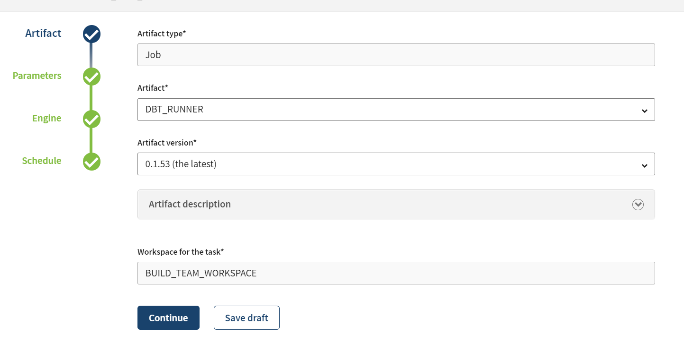

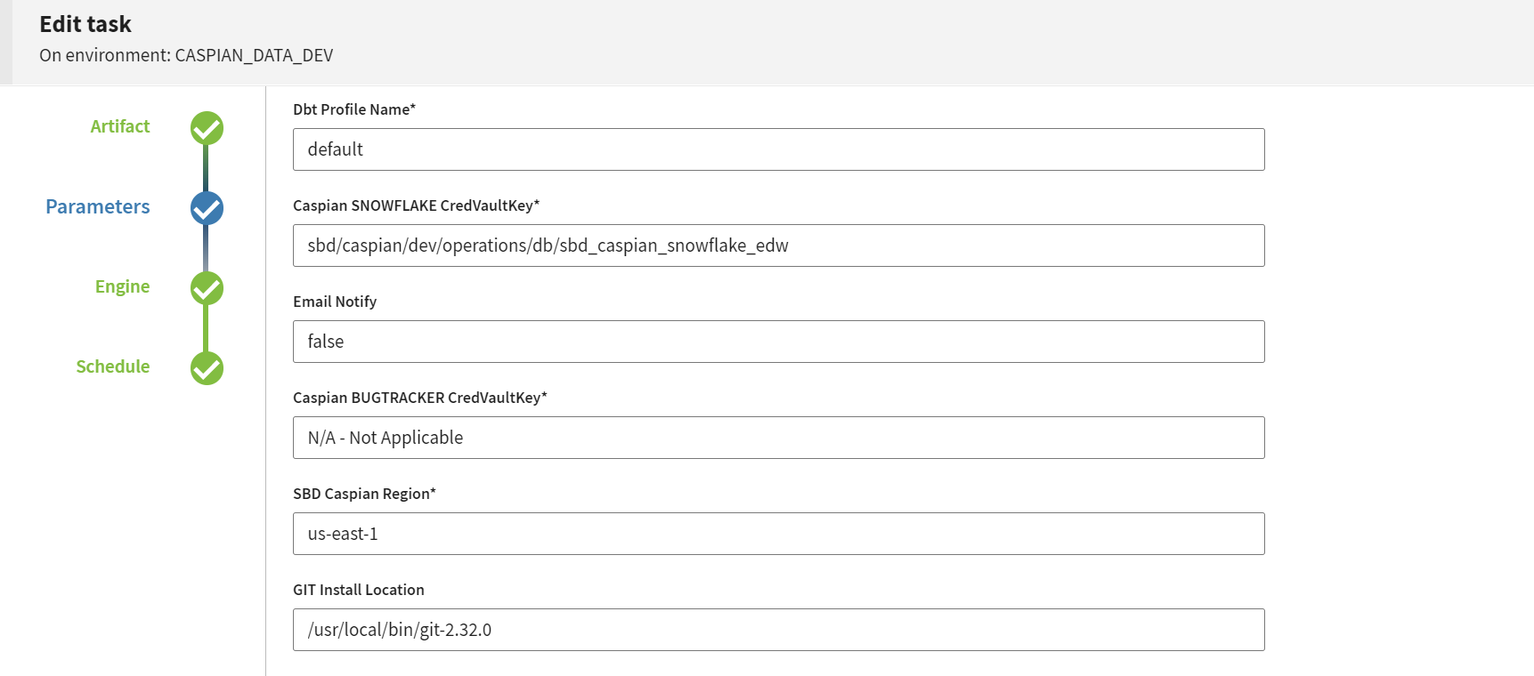

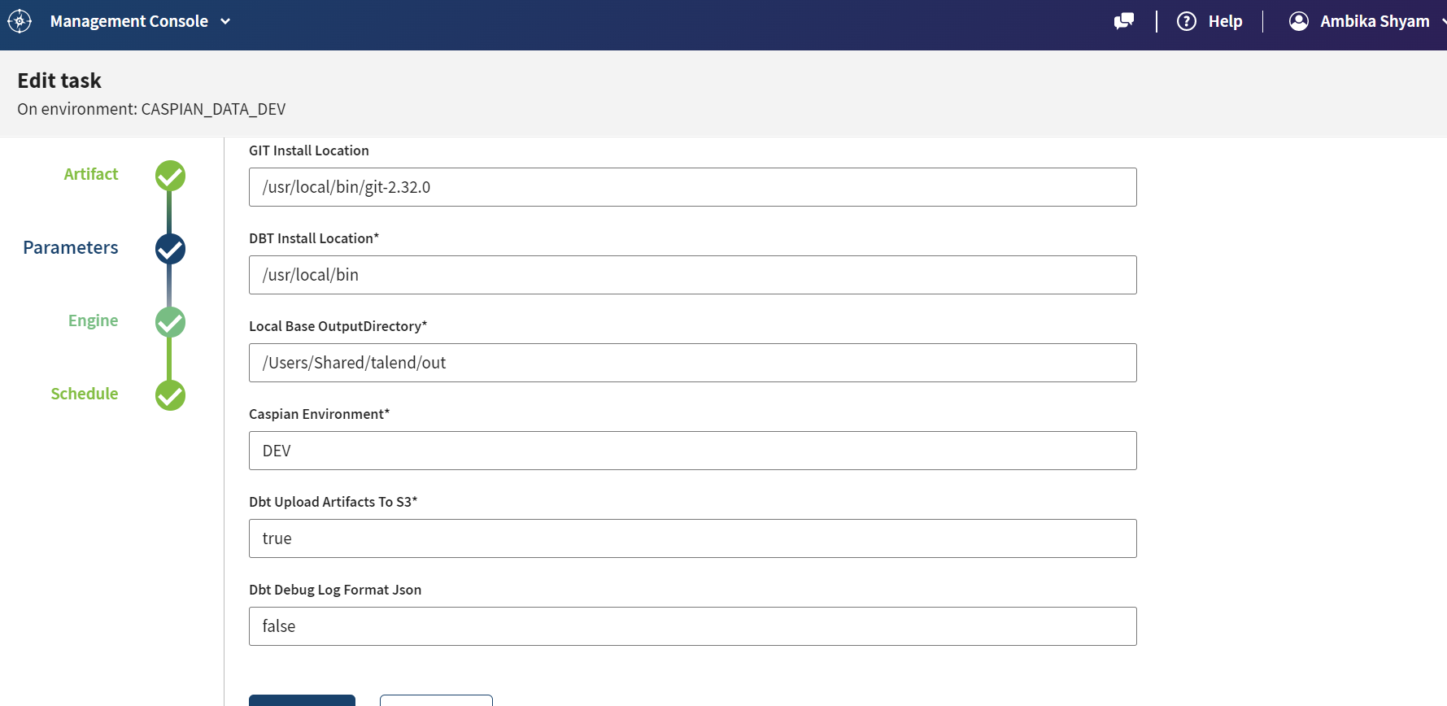

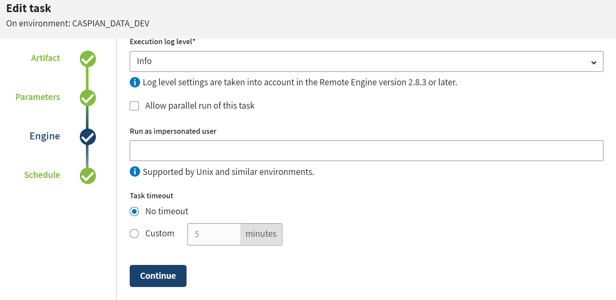

Demerits☹risk in stackline

1. Sales table don’t have data but ratings table have data for that
2. For which week sales is not done

Things done by bala (after model creation)

1. He developed the code for stackline (in loaddts – least())
2. he changed all the cols as (varchar) like (:: varchar)
3. he took out weekending as weekid (in stackline) as it was creating issue
4. he included currency (with clause) to compare with retailer id()
5. he created # for other tables (promo_type) and promotype already in promotions)
6. after this he changed the code (to compare the source and target)
7. he helped me to get git status for capsian folder and git commit and git switch to feature/prowl-stackline-seq and git pull to point to feature branch
8. now he has updated master branch as empty and kept the branches ready for migration.

Things done by Ambika (after model creation)

1. before (setting the least(loaddts) and individual col ::varchar)
2. I merged the view (given by bala and put in the stackline) and build the model
3. I was trying to keep all the cols in the view and try building the model and got the col values in SF
4. Wrote the Sf date code for weekid
5. Went through the unit test results and run book of pricing team and

And produced the same in pricing competitor sales

Done with cut over plan

1. Handled the queries given by the sheetal (out of 3, 2 was correct)
2. A. Target count greater than source (because they failed to check union query)

b. src_create_date (was varchar) and change it to timestamp (by using to_timestanmp (suggested) and rerun the stackline and brought the unit test results

c. brought the code to the code (checking inner join of the key cols) and retailsprice <> p.retailprice (this alone missed)

1. Tried the source and target count query (using rec_hash_key) from test_edw and concat(keys cols) in prod_raw

How to create talend task :

Step 1:

In production (branch) we are going to run the TMC task in master or

If we can run the TMC task in feature branch and then into master

(repo branch)

Repo change:

1. (through source tree keeping master branch clean and branches ready)

2. 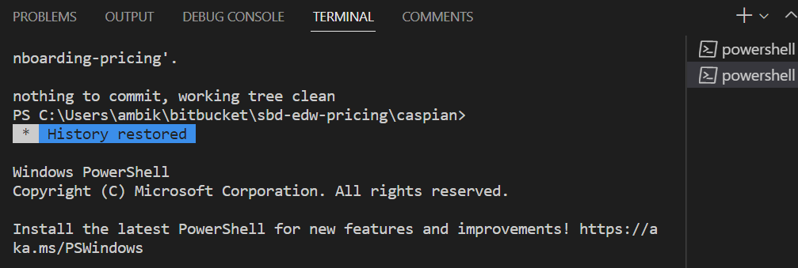

This screen should be maintained in VS ( for edw-pricing-main) and capsian folder pointing to

GIT current (feature branch) and up to date

1. When we are doing migration to prod_edw (whatever the new cols we have introduced in test_edw that should not be there
2. desc table "PROD_EDW"."CONSOLIDATED"."EDW_PRICING_COMPETITOR_SALES"
3. DESC TABLE TEST_EDW.CONSOLIDATED.EDW_PRICING_COMPETITOR_SALES
4. We need to check the above two query to confirm it

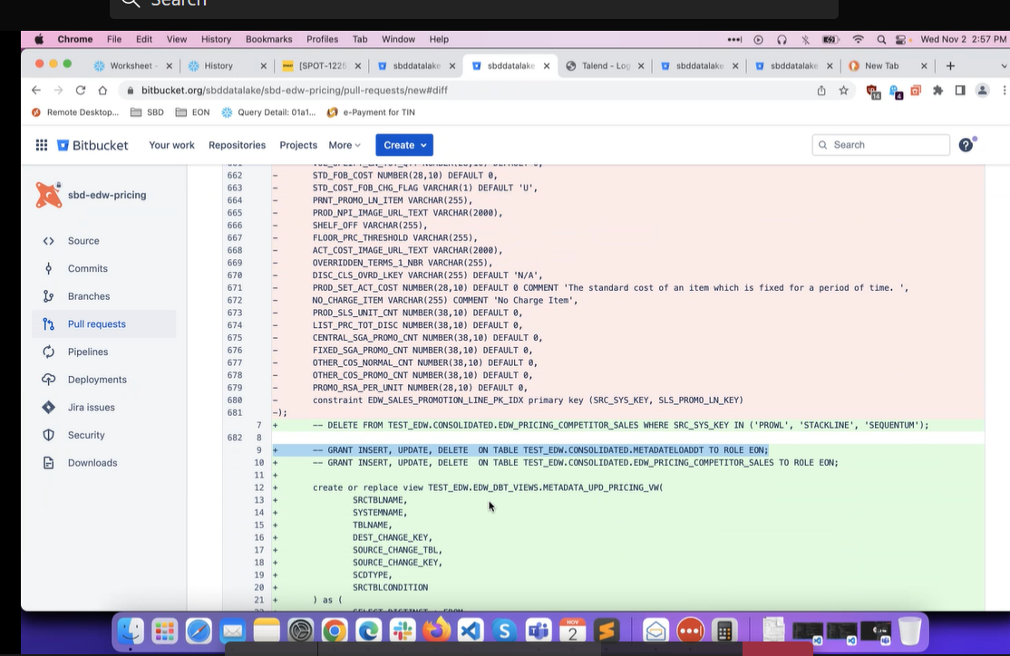

Go to source tree

Fetch from master

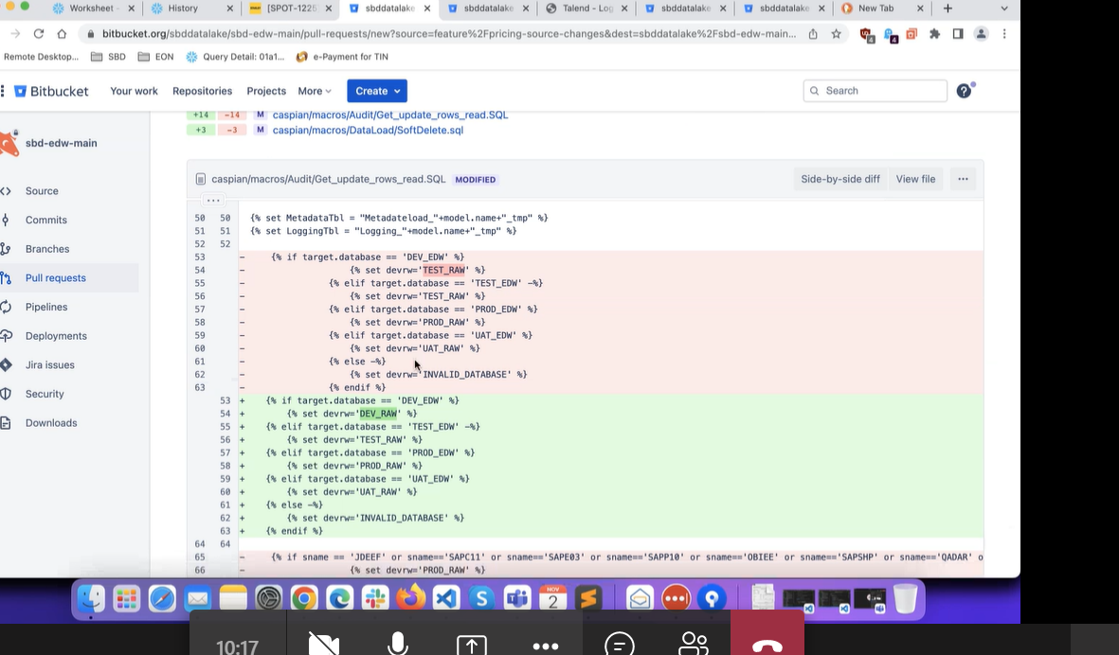

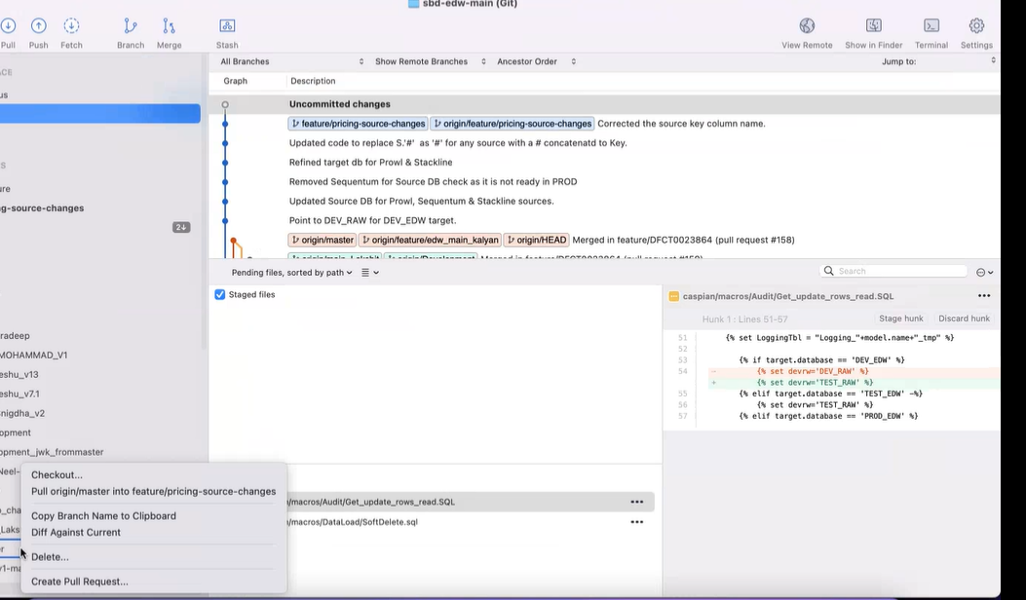



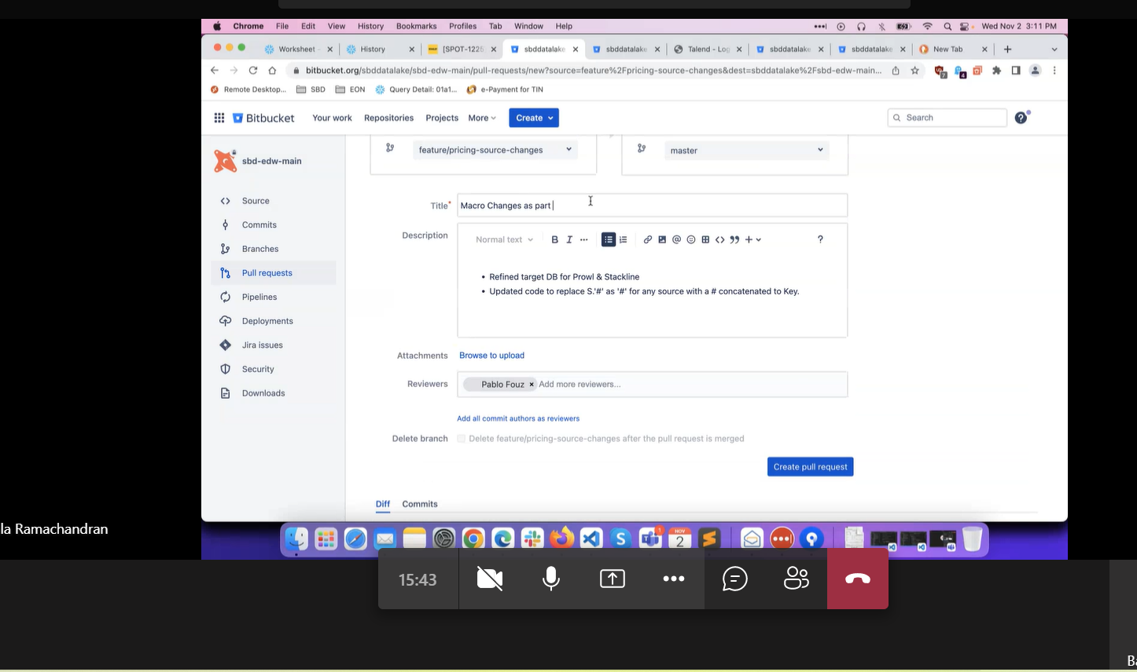

How to clean the master branch in git

git clone <https://your_repo_url/>

git status #check if you are in master branch.

git branch clean_up

git checkout clean_up

git rm . #remove all files from current folder.

git rm -r * #remove all folder and their data.

git checkout master

git merge clean_up

git branch -d clean_up

git push

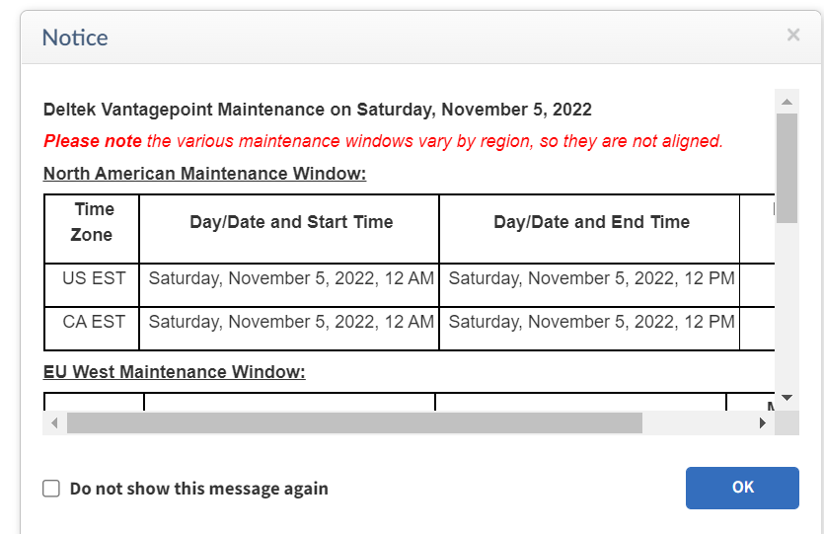

PRODUCTION QUERIES:

--production queries

use database prod_edw

use schema consolidated

use database prod_raw

desc table "PROD_EDW"."CONSOLIDATED"."EDW_PRICING_COMPETITOR_SALES"

DESC TABLE TEST_EDW.CONSOLIDATED.EDW_PRICING_COMPETITOR_SALES

--target count

select COUNT(*) from "PROD_EDW"."CONSOLIDATED"."EDW_PRICING_COMPETITOR_SALES" where SRC_SYS_KEY = 'PROWL'

select COUNT(*) from "PROD_EDW"."CONSOLIDATED"."EDW_PRICING_COMPETITOR_SALES" where SRC_SYS_KEY = 'SEQUENTUM'

select COUNT(*) from "PROD_EDW"."CONSOLIDATED"."EDW_PRICING_COMPETITOR_SALES" where SRC_SYS_KEY = 'STACKLINE'

--prowl (source count)

select COUNT(*) from "PROD_RAW"."PROWL"."PROWL_FULL_URL_LIST_CANADA" where reports = 'Y'

union

select COUNT(*) from "PROD_RAW"."PROWL"."PROWL_FULL_URL_LIST_US" where reports = 'Y'

--unit test query

select MODEL_NAME, LOADSTATUS, ROWREAD, ROWINSERTED, ROWUPDATED, ERROR_DESCRIPTION, job_time_start, job_time_end

from "PROD_EDW"."CONSOLIDATED"."LOGGING" where LID in

(Select SID from "PROD_EDW"."CONSOLIDATED"."METADATELOADDT" where SYSTEM_NAME LIKE '%PROWL%')

and MODEL_NAME like '%PRICING%' and ERROR_DESCRIPTION IS NULL and LOADSTATUS='END'

order by job_time_start desc

--sequentum (source sount)

WITH DEDUPE_SRC_AMZ_US as (

SELECT *,

ROW_NUMBER() OVER(PARTITION BY INTERNETNR, MODELNR, ITEMMODELNUMBER, ITEMURL, RUNDATE

ORDER BY INTERNETNR, MODELNR, ITEMMODELNUMBER, ITEMURL, RUNDATE, ROW_SQN DESC) AS ROW_NO

FROM PROD_RAW.SEQUENTUM.VW_AMAZON_US_COMPR_PRODUCTS

), DEDUPE_SRC_AMZ_CA as (

SELECT *,

ROW_NUMBER() OVER(PARTITION BY INTERNETNR, MODELNR, ITEMMODELNUMBER, ITEMURL, RUNDATE

ORDER BY INTERNETNR, MODELNR, ITEMMODELNUMBER, ITEMURL, RUNDATE, ROW_SQN DESC) AS ROW_NO

FROM PROD_RAW.SEQUENTUM.VW_AMAZON_CA_COMPR_PRODUCTS

), DEDUPE_SRC_LS_PRC as (

SELECT *,

ROW_NUMBER() OVER(PARTITION BY SKU, MODELNUMBER, ITEMBRAND, ITEMURL, RUNDATE

ORDER BY SKU, MODELNUMBER, ITEMBRAND, ITEMURL, RUNDATE, ROW_SQN DESC) AS ROW_NO

FROM PROD_RAW.SEQUENTUM.VW_LOWES_PRICING

), DEDUPE_SRC_HD_PRC as (

SELECT *,

ROW_NUMBER() OVER(PARTITION BY SKU, MODELNUMBER, ITEMBRAND, ITEMURL, RUNDATE

ORDER BY SKU, MODELNUMBER, ITEMBRAND, ITEMURL, RUNDATE, ROW_SQN DESC) AS ROW_NO

FROM PROD_RAW.SEQUENTUM.VW_HOMEDEPOT_PRICING

), DEDUPE_SRC_HD_COMPR as (

SELECT *,

ROW_NUMBER() OVER(PARTITION BY INTERNETNR, MODELNR, ITEMBRAND, ITEMURL, RUNDATE

ORDER BY INTERNETNR, MODELNR, ITEMBRAND, ITEMURL, RUNDATE, ROW_SQN DESC) AS ROW_NO

FROM PROD_RAW.SEQUENTUM.VW_HOMEDEPOT_COMPR_PRODUCTS

), DEDUPE_SRC_LS_COMPR as (

SELECT *,

ROW_NUMBER() OVER(PARTITION BY INTERNETNR, MODELNR, ITEMBRAND, ITEMURL, RUNDATE

ORDER BY INTERNETNR, MODELNR, ITEMBRAND, ITEMURL, RUNDATE, ROW_SQN DESC) AS ROW_NO

FROM PROD_RAW.SEQUENTUM.VW_LOWES_COMPR_PRODUCTS

)

SELECT 'AMZ_US', COUNT(*) AS SOURCECOUNT

FROM DEDUPE_SRC_AMZ_US --1

WHERE ROW_NO = 1

UNION ALL

SELECT 'AMZ_CA', COUNT(*)

FROM DEDUPE_SRC_AMZ_CA --2

WHERE ROW_NO = 1

UNION ALL

SELECT 'HD_PRC', COUNT(*)

FROM DEDUPE_SRC_HD_PRC --3

WHERE ROW_NO = 1

UNION ALL

SELECT 'LS_PRC', COUNT(*)

FROM DEDUPE_SRC_LS_PRC --4

WHERE ROW_NO = 1

UNION ALL

SELECT 'HD_COMPR', COUNT(*)

FROM DEDUPE_SRC_HD_COMPR --5

WHERE ROW_NO = 1

UNION ALL

SELECT 'LS_COMPR', COUNT(*)

FROM DEDUPE_SRC_LS_COMPR --6

WHERE ROW_NO = 1;

--unit test query

select MODEL_NAME, LOADSTATUS, ROWREAD, ROWINSERTED, ROWUPDATED, ERROR_DESCRIPTION, job_time_start, job_time_end

from "PROD_EDW"."CONSOLIDATED"."LOGGING" where LID in

(Select SID from "PROD_EDW"."CONSOLIDATED"."METADATELOADDT" where SYSTEM_NAME LIKE '%SEQUENTUM%')

and MODEL_NAME like '%PRICING%' and ERROR_DESCRIPTION IS NULL and LOADSTATUS='END'

order by job_time_start desc

-- stackline (source count)

SELECT COUNT(*) FROM "PROD_RAW"."STACKLINE"."CONTENTSCORE"

UNION

SELECT COUNT(*) FROM "PROD_RAW"."STACKLINE"."SALES"

UNION

SELECT COUNT(*) FROM "PROD_RAW"."STACKLINE"."PROMOTIONS"

UNION

SELECT COUNT(*) FROM "PROD_RAW"."STACKLINE"."RATINGSREVIEWS"

with output as (

select RCRD_HASH_KEY from PROD_EDW.CONSOLIDATED.EDW_PRICING_COMPETITOR_SALES

WHERE SRC_SYS_KEY = 'STACKLINE' AND RCRD_HASH_KEY IN

(SELECT(md5(CONCAT(COALESCE(S.RETAILERSKU::VARCHAR,''),

'~',COALESCE(S.RETAILERID::VARCHAR,''),

'~',COALESCE(S.WEEKID::VARCHAR,''),

'~',COALESCE('#'::VARCHAR,''))))

FROM "PROD_RAW"."STACKLINE"."SALES" AS S)

UNION

select RCRD_HASH_KEY from PROD_EDW.CONSOLIDATED.EDW_PRICING_COMPETITOR_SALES

WHERE SRC_SYS_KEY = 'STACKLINE' AND RCRD_HASH_KEY IN

(SELECT(md5(CONCAT(COALESCE(P.RETAILERSKU::VARCHAR,''),

'~',COALESCE(P.RETAILERID::VARCHAR,''),

'~',COALESCE(P.WEEKID::VARCHAR,''),

'~',COALESCE(P.PROMOTYPE::VARCHAR,''))))

FROM "PROD_RAW"."STACKLINE"."PROMOTIONS" AS P)

UNION

select RCRD_HASH_KEY from PROD_EDW.CONSOLIDATED.EDW_PRICING_COMPETITOR_SALES

WHERE SRC_SYS_KEY = 'STACKLINE' AND RCRD_HASH_KEY IN

(SELECT(md5(CONCAT(COALESCE(R.RETAILERSKU::VARCHAR,''),

'~',COALESCE(R.RETAILERID::VARCHAR,''),

'~',COALESCE(R.WEEKID::VARCHAR,''),

'~',COALESCE('#'::VARCHAR,''))))

FROM "PROD_RAW"."STACKLINE"."RATINGSREVIEWS" AS R)

UNION

select RCRD_HASH_KEY from PROD_EDW.CONSOLIDATED.EDW_PRICING_COMPETITOR_SALES

WHERE SRC_SYS_KEY = 'STACKLINE' AND RCRD_HASH_KEY IN

(SELECT(md5(CONCAT(COALESCE(CS.RETAILERSKU::VARCHAR,''),

'~',COALESCE(CS.RETAILERID::VARCHAR,''),

'~',COALESCE(CS.WEEKID::VARCHAR,''),

'~',COALESCE('#'::VARCHAR,''))))

FROM "PROD_RAW"."STACKLINE"."CONTENTSCORE" AS CS)

)

SELECT COUNT(*) as SOURCE_COUNT, sum(0) as TARGET_COUNT FROM output AS R

UNION ALL

SELECT SUM(0) as SOURCE_COUNT, COUNT(*) as TARGET_COUNT FROM PROD_EDW.CONSOLIDATED.EDW_PRICING_COMPETITOR_SALES

where SRC_SYS_KEY = 'STACKLINE'

and CURR_RCRD_FLAG = 'Y'

--unit test query

select MODEL_NAME, LOADSTATUS, ROWREAD, ROWINSERTED, ROWUPDATED, ERROR_DESCRIPTION, job_time_start, job_time_end

from "PROD_EDW"."CONSOLIDATED"."LOGGING" where LID in

(Select SID from "PROD_EDW"."CONSOLIDATED"."METADATELOADDT" where SYSTEM_NAME LIKE '%STACKLINE%')

and MODEL_NAME like '%PRICING%' and ERROR_DESCRIPTION IS NULL and LOADSTATUS='END'

order by job_time_start desc

BALA’S QUERY:

WITH STACKLINE_RETAILERS AS

( SELECT RETAILERID,

RETAILERSKU,

WEEKID,

'#' as SLS_PROMO_TYPE

FROM "PROD_RAW"."STACKLINE"."SALES"

-- WHERE WEEKID >= 202231

UNION

SELECT RETAILERID,

RETAILERSKU,

WEEKID,

PROMOTYPE as SLS_PROMO_TYPE

FROM "PROD_RAW"."STACKLINE"."PROMOTIONS"

--WHERE WEEKID >= 202231

UNION

SELECT RETAILERID,

RETAILERSKU,

WEEKID,

'#' as SLS_PROMO_TYPE

FROM "PROD_RAW"."STACKLINE"."RATINGSREVIEWS"

--WHERE WEEKID >= 202231

UNION

SELECT RETAILERID,

RETAILERSKU,

WEEKID,

'#' as SLS_PROMO_TYPE

FROM "PROD_RAW"."STACKLINE"."CONTENTSCORE"

-- WHERE WEEKID >= 202230

)

SELECT SUM(SOURCE_COUNT) AS PROD_RAW_SOURCE_COUNT,

SUM(TARGET_COUNT) AS TEST_EDW_TARGET_COUNT

FROM (

SELECT COUNT(*) as SOURCE_COUNT, sum(0) as TARGET_COUNT FROM STACKLINE_RETAILERS AS R

UNION ALL

SELECT SUM(0) as SOURCE_COUNT, COUNT(*) as TARGET_COUNT FROM test_EDW.CONSOLIDATED.EDW_PRICING_COMPETITOR_SALES

where SRC_SYS_KEY = 'STACKLINE'

and CURR_RCRD_FLAG = 'Y'

);